

**LAB OOPS CONCEPTS**

**COURSE NAME:** **Modern Programming Language**

**DEGREE:** **BS (SE) - 5B / MORNING**

**SUBMITTED TO:** **Ms. Aimen Khan**

**SUBMITTION DATE: 14-November-2022**

**SUBMITTED BY: Shawal Ahmed**

**ARID NO: 20-ARID-827**

**Source Code:**

**/* Online Java Compiler and Editor */**

**class student{**

**String name;**

**int id;**

**}**

**public class JavaApplication6**

**{**

**public static void main(String[] args)**

**{**

**student s1= new student();**

**System.out.println(s1.id);**

**System.out.println(s1.name);**

**System.out.println("SHawal Ahmed(20-ARID-821)");**

**}**

**}**

**Output:**

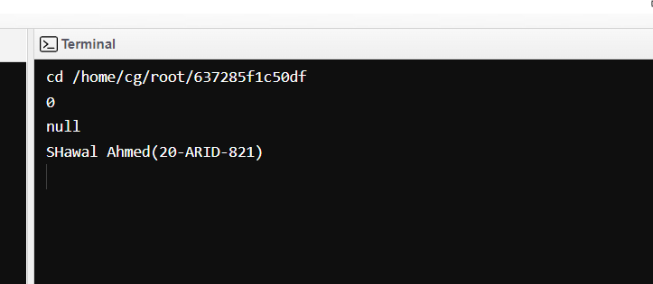

**Source Code:**

**/* Online Java Compiler and Editor */**

**class student{**

**String name;**

**int id;**

**}**

**public class JavaApplication6**

**{**

**public static void main(String[] args)**

**{**

**student s1= new student();**

**student s2= new student();**

**s1.id=827;**

**s1.name="Shawal";**

**s2.id=827;**

**s2.name="Ahmed";**

**System.out.println(s1.id+" "+s1.name);**

**System.out.println(s2.id+" "+s2.name);**

**System.out.println("Shawal Ahmed(20-ARID-827)");**

**}**

**}**

**Output:**

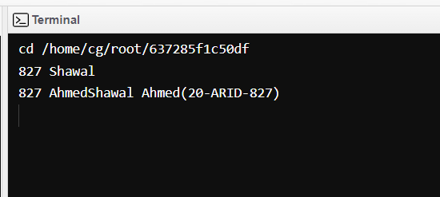

**Source Code:**

**class student{**

**int rollno;**

**String name;**

**void insertRecord(int r, String n)**

**{**

**rollno=r;**

**name=n;**

**}**

**void displayinfomation()**

**{**

**System.out.println(rollno+" " +name);**

**}**

**}**

**public class JavaApplication6**

**{**

**public static void main(String[] args)**

**{**

**student s1= new student();**

**student s2= new student();**

**s1.insertRecord(827,"Shawal Ahmed");**

**s2.insertRecord(728, "Ahmed Shawal");**

**s1.displayinfomation();**

**s2.displayinfomation();**

**System.out.println("Shawal Ahmed(20-ARID-827)");**

**}**

**}**

**Output:**

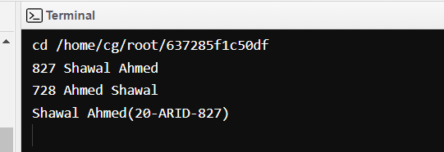

**Source Code:**

**/* Online Java Compiler and Editor */**

**class Employee{**

**int id;**

**String name;**

**float salary;**

**Employee(int i, String n, float s)**

**{**

**id=i;**

**name=n;**

**salary=s;**

**}**

**void display()**

**{**

**System.out.println(id+" "+name+" "+salary);**

**}**

**}**

**public class JavaApplication6**

**{**

**public static void main(String[] args)**

**{**

**Employee e1=new Employee(827,"Shawal",55000);**

**Employee e2=new Employee(827,"Ahmed",46000);**

**Employee e3=new Employee(827,"Ahmed",74000);**

**e1.display();**

**e2.display();**

**e3.display();**

**System.out.println("Shawal Ahmed(20-ARID-827)");**

**}**

**}**

**Output:**

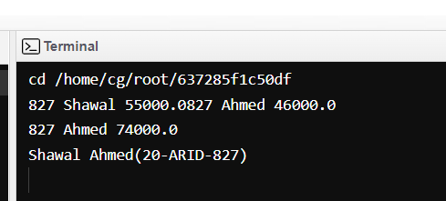

**Source Code:**

**class Bike1{**

**Bike1()**

**{**

**System.out.println("Bike is Created");**

**}**

**}**

**public class JavaApplication6**

**{**

**public static void main(String[] args)**

**{**

**Bike1 b1 = new Bike1();**

**System.out.println("Shawal Ahmed(20-ARID-827)");**

**}**

**}**

**Output:**

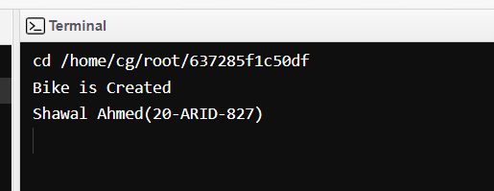

**Source Code:**

**class Student3{**

**int id;**

**String name;**

**void display()**

**{**

**System.out.println(id+" "+name);**

**}**

**}**

**public class JavaApplication6**

**{**

**public static void main(String[] args)**

**{**

**Student3 s1 =new Student3();**

**Student3 s2 =new Student3();**

**s1.display();**

**s2.display();**

**System.out.println("Shawal Ahmed(20-ARID-827)");**

**}**

**}**

**Output:**

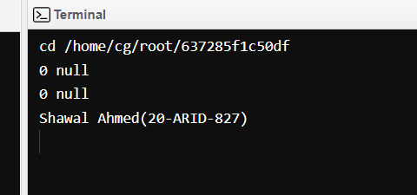

**Source code:**

**class Student4{**

**int id;**

**String name;**

**Student4(int id , String name)**

**{**

**this.id=id;**

**this.name=name;**

**}**

**void display()**

**{**

**System.out.println(id+" "+name);**

**}**

**}**

**public class JavaApplication6**

**{**

**public static void main(String[] args)**

**{**

**Student4 s1 =new Student4(827,"Shawal");**

**Student4 s2 =new Student4(728,"Ahmed");**

**s1.display();**

**s2.display();**

**System.out.println("Shawal Ahmed(20-ARID-827)");**

**}**

**}**

**Output:**

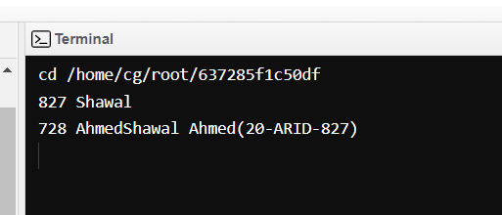

**Source Code:**

**class Student5{**

**int id;**

**String name;**

**int age;**

**Student5(int i,String n){**

**id = i;**

**name = n;**

**}**

**Student5(int i,String n,int a){**

**id = i;**

**name = n;**

**age=a;**

**}**

**void display()**

**{**

**System.out.println(id+" "+name+" "+age);**

**}**

**}**

**public class JavaApplication6**

**{**

**public static void main(String[] args)**

**{**

**Student5 s1 = new Student5(827,"Shawal");**

**Student5 s2 = new Student5(728,"Ahmed",34);**

**s1.display();**

**s2.display();**

**System.out.println("Shawal Ahmed(20-ARID-827)");**

**}**

**}**

**Output:**

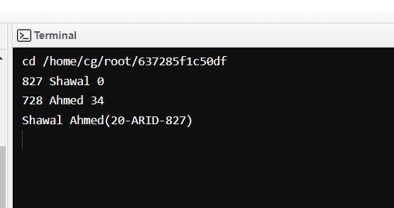

**Source Code:**

**class Adder{**

**static int add(int a, int b)**

**{**

**return a+b;**

**}**

**static int add(int a, int b, int c)**

**{**

**return a+b+c;**

**}**

**}**

**public class JavaApplication6**

**{**

**public static void main(String[] args)**

**{**

**System.out.println(Adder.add(22,22));**

**System.out.println(Adder.add(22,22,22));**

**System.out.println("Shawal Ahmed(20-ARID-827)");**

**}**

**}**

**Output:**

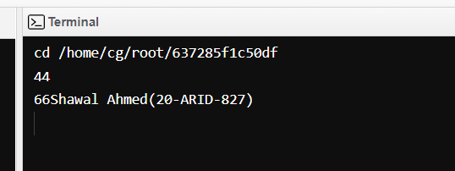

**Source Code:**

**class Adder{**

**static int add(int a, int b)**

**{**

**return a+b;**

**}**

**static double add(double a, double b)**

**{**

**return a+b;**

**}**

**}**

**public class JavaApplication6**

**{**

**public static void main(String[] args)**

**{**

**System.out.println(Adder.add(11,22));**

**System.out.println(Adder.add(12.3,12.6));**

**System.out.println("Shawal Ahmed(20-ARID-827)");**

**}**

**}**

**Output:**

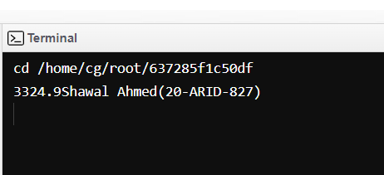

**Source Code:**

**class Student{**

**private String name;**

**public String getname()**

**{**

**return name;**

**}**

**public void setname(String name)**

**{**

**this.name=name;**

**}**

**}**

**public class JavaApplication6**

**{**

**public static void main(String[] args)**

**{**

**Student s= new Student();**

**s.setname("Shawal Ahmed");**

**System.out.println(s.getname());**

**System.out.println("Shawal Ahmed(20-ARID-827)");**

**}**

**}**

**Output:**

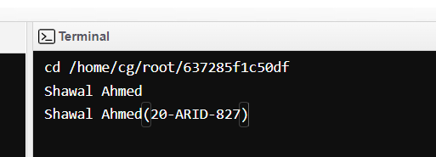

**Source Code:**

**class Employee{**

**float salary=40000;**

**}**

**class Programmer extends Employee**

**{**

**int bonus=10000;**

**}**

**public class JavaApplication6**

**{**

**public static void main(String[] args)**

**{**

**Programmer p = new Programmer();**

**System.out.println("Programmer Salary is :"+ p.salary);**

**System.out.println("Bonus of Programmer is :"+ p.bonus);**

**System.out.println("Shawal Ahmed(20-ARID-827)");**

**}**

**}**

**Output:**

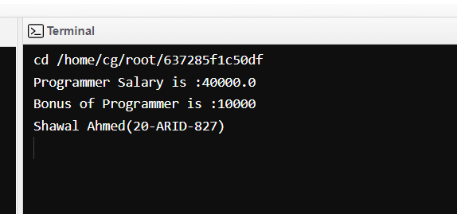

**Source Code:**

**class Animal{**

**void eat()**

**{**

**System.out.println("Eating...");**

**}**

**}**

**class Dog extends Animal{**

**void bark()**

**{**

**System.out.println("Barking...");**

**}**

**}**

**public class JavaApplication6**

**{**

**public static void main(String[] args)**

**{**

**Dog d = new Dog();**

**d.bark();**

**d.eat();**

**System.out.println("Shawal Ahmed(20-ARID-827)");**

**}**

**}**

**Output:**

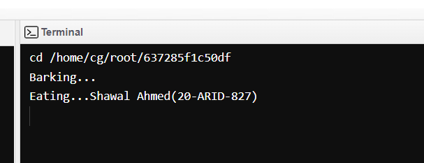

**Source Code:**

**class Animal{**

**void eat()**

**{**

**System.out.println("Eating...");**

**}**

**}**

**class Dog extends Animal{**

**void bark()**

**{**

**System.out.println("Barking...");**

**}**

**}**

**class BabyDog extends Dog{**

**void weep()**

**{**

**System.out.println("Weeping...");**

**}**

**}**

**public class JavaApplication6**

**{**

**public static void main(String[] args)**

**{**

**BabyDog d = new BabyDog();**

**d.weep();**

**d.bark();**

**d.eat();**

**System.out.println("Shawal Ahmed(20-ARID-827)");**

**}**

**}**

**Output:**

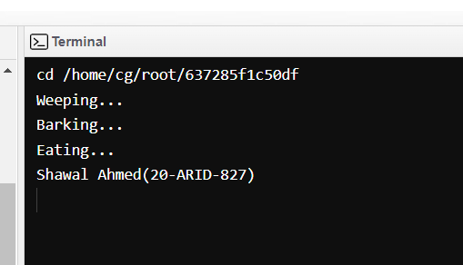

**Source Code:**

**class Animal{**

**void eat()**

**{**

**System.out.println("Eating...");**

**}**

**}**

**class Dog extends Animal{**

**void bark()**

**{**

**System.out.println("Barking...");**

**}**

**}**

**class Cat extends Animal{**

**void Meow()**

**{**

**System.out.println("Meowing...");**

**}**

**}**

**public class JavaApplication6**

**{**

**public static void main(String[] args)**

**{**

**Cat c = new Cat();**

**c.Meow();**

**c.eat();**

**System.out.println("Shawal Ahmed(20-ARID-827)");**

**}**

**}**

**Output:**

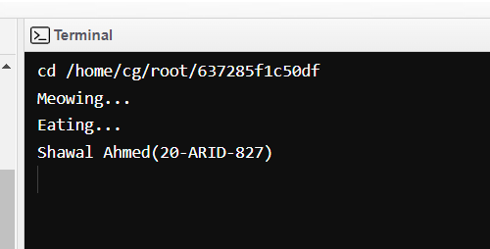

**Source Code:**

**abstract class Bike{**

**abstract void run();**

**}**

**class Honda4 extends Bike**

**{**

**@Override**

**void run()**

**{**

**System.out.println("Bike is Running Safely");**

**}**

**}**

**public class JavaApplication6**

**{**

**public static void main(String[] args)**

**{**

**Bike obj =new Honda4();**

**obj.run();**

**System.out.println("Shawal Ahmed(20-ARID-827)");**

**}**

**}**

**Output:**

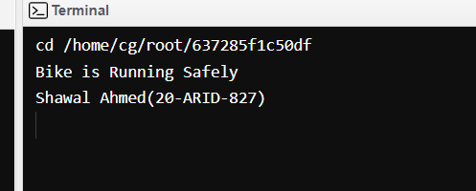

**Source Code:**

**abstract class Shape{**

**abstract void draw();**

**}**

**class Rectangle extends Shape**

**{**

**@Override**

**void draw()**

**{**

**System.out.println("drawing rectangle");**

**}**

**}**

**class Circle1 extends Shape{**

**@Override**

**void draw()**

**{**

**System.out.println("drawing circle");**

**}**

**}**

**public class JavaApplication6**

**{**

**public static void main(String[] args)**

**{**

**Shape s = new Circle1();**

**s.draw();**

**System.out.println("Shawal Ahmed(20-ARID-827)");**

**}**

**}**

**Output:**

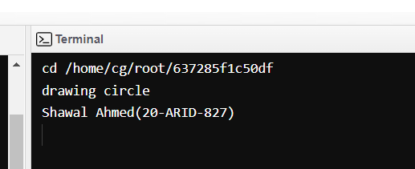

**Source Code:**

**interface printable**

**{**

**void print();**

**}**

**class A6 implements printable{**

**@Override**

**public void print()**

**{**

**System.out.println("Hello SHawal!");**

**}**

**}**

**public class JavaApplication6**

**{**

**public static void main(String[] args)**

**{**

**A6 obj= new A6();**

**obj.print();**

**System.out.println("Shawal Ahmed(20-ARID-827)");**

**}**

**}**

**Output:**

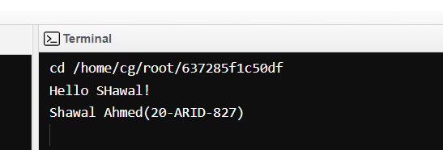

**Source Code:**

**interface Drawable**

**{**

**void draw();**

**}**

**class Rectangle implements Drawable{**

**@Override**

**public void draw()**

**{**

**System.out.println("Drawing Rectangle");**

**}**

**}**

**class Circle implements Drawable{**

**@Override**

**public void draw()**

**{**

**System.out.println("Drawing Circle");**

**}**

**}**

**public class JavaApplication6**

**{**

**public static void main(String[] args)**

**{**

**Drawable d= new Circle();**

**d.draw();**

**System.out.println("Shawal Ahmed(20-ARID-827)");**

**}**

**}**

**Output:**

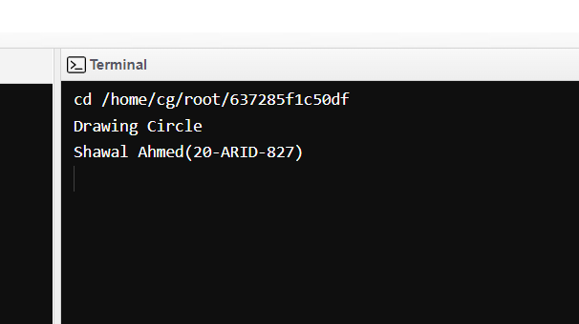

**Source Code:**

**interface Printable**

**{**

**void Print();**

**}**

**interface Showable**

**{**

**void Show();**

**}**

**class A7 implements Printable, Showable{**

**@Override**

**public void Print()**

**{**

**System.out.println("Hello");**

**}**

**@Override**

**public void Show()**

**{**

**System.out.println("Welcome");**

**}**

**}**

**public class JavaApplication6**

**{**

**public static void main(String[] args)**

**{**

**A7 obj = new A7();**

**obj.Print();**

**obj.Show();**

**System.out.println("Shawal Ahmed(20-ARID-827)");**

**}**

**}**

**Output:**

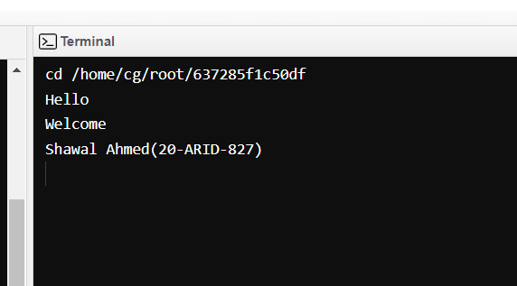

**Source Code:**

**interface Printable**

**{**

**void Print();**

**}**

**interface Showable extends Printable**

**{**

**void Show();**

**}**

**class interface4 implements Showable**

**{**

**@Override**

**public void Print()**

**{**

**System.out.println("Hello");**

**}**

**@Override**

**public void Show()**

**{**

**System.out.println("Welcome");**

**}**

**}**

**public class JavaApplication6**

**{**

**public static void main(String[] args)**

**{**

**interface4 obj = new interface4();**

**obj.Print();**

**obj.Show();**

**System.out.println("Shawal Ahmed(20-ARID-827)");**

**}**

**}**

**Output:**

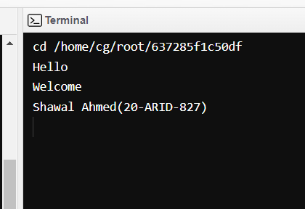

**Source Code:**

**class outerclass**

**{**

**int x=10;**

**class innerclass**

**{**

**int y=5;**

**}**

**}**

**public class JavaApplication6**

**{**

**public static void main(String[] args)**

**{**

**outerclass myouter = new outerclass();**

**outerclass.innerclass myinner= myouter.new innerclass();**

**System.out.println("Inner Class Varibale :"+myinner.y+"\nOuter Class Varibale"+ myouter.x);**

**System.out.println("Shawal Ahmed(20-ARID-827)");**

**}**

**}**

**Output:**

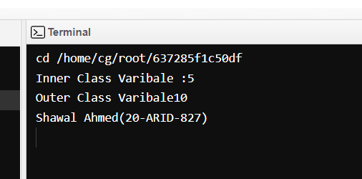

**Source Code:**

**abstract class person**

**{**

**abstract void eat();**

**}**

**public class JavaApplication6**

**{**

**public static void main(String[] args)**

**{**

**person p = new person(){**

**@Override**

**void eat(){**

**System.out.println("Nice Fruits");**

**}**

**};**

**p.eat();**

**System.out.println("Shawal Ahmed(20-ARID-827)");**

**}**

**}**

**Output:**

